# 10. Towards the Network Commons (Conclusions)

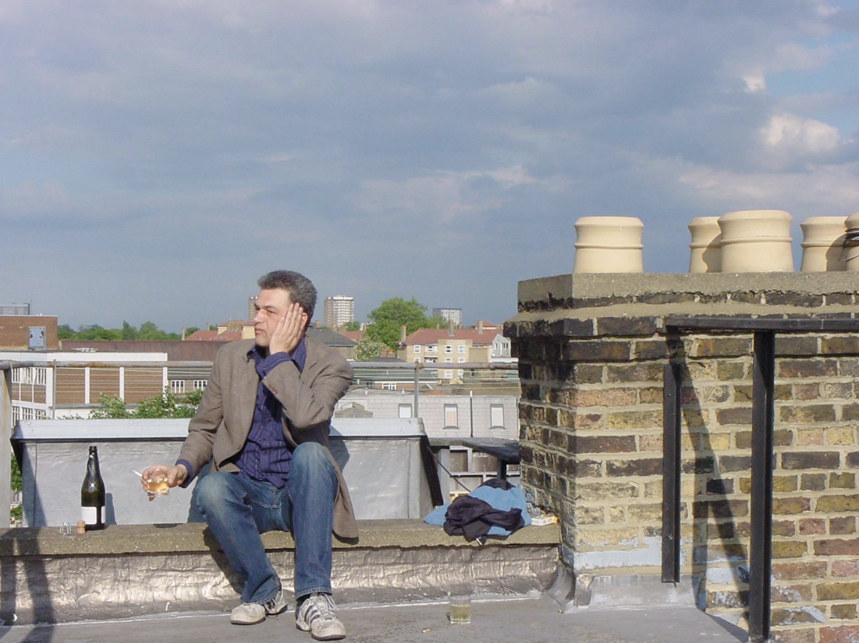Fig. 30. Andrews Road, London, May 2005 (from Monoskop[1]).

Based on a recent trip to Germany, where vibrant new communities have triggered discussions about what makes the essence of Freifunk, I am suggesting that the future of wireless community networks lies in the notion of the Network Commons.

In the course of this book project, I have studied wireless (and wired) community networks trying to establish the current status of this movement. Two main research questions have guided my inquiry. First, I wanted to see if and how wireless community networks connect with larger questions such as communications freedom; and second, I wanted to find out if those networks can play a role regarding the democratization of technology. This second question has two aspects. One regards the development of technology itself. Wireless community networkers are not just consumers and users of technology, they are also actively developing it. My question was, if technologies, developed by a community, are fundamentally different from technologies developed by companies and what would make such a qualitative difference. The second aspect regarding the democratization of technology concerns the role and function the respective technology plays within a community of users. In informational capitalism, technology in general and ICT in particular are key social agents. They are not just neutral tools but connected with wider social issues. Intricate knowledge of technologies, however, is restricted to narrow strata of society. The gap between high-priests of ICT and users, for whom it is a black box, goes across society and political divides. My assumption is that a lack of knowledge also furthers other inequalities, economic and political ones. If wireless community networks thus further knowledge about network technologies, because the development and application is embedded in a wider community, then it could be said that they further the *socialization of technologies*.

When starting this study, I soon became aware that any proper method applied to the research question would require vast quantities of empirical research which, due to the limitations of this project, I would be unable to conduct. It would require, for instance, to gather comprehensive empirical evidence about who participates in those networks, what their backgrounds are and which ways of participation exist. That would mean to engage in field work doing hundreds, not dozens of interviews. My work has been supported by an EU grant in the context of the CONFINE project. I was employed by Verein Funkfeuer, Vienna, on a part-time contract of less than one working day per week for 14 months. I thus soon decided that I could only do qualitative research. My main methodology used was participatory observation, conducted through interviews, research visits, websites, and mailinglists. I conducted about 20 interviews of different lengths and intensity.

By and large I think that my research questions have been validated. Those were interesting questions to ask and they merit further attention. However, the nature of my research questions does not allow for a yes or no type answer. Any answer would necessarily be a complex assessment of a complex matter. My main case studies were Freifunk, Germany, and Guifi, Spain. In both projects, people are at work who share a certain set of ethics and their goals coincide with my research questions. They are building wireless community networks with the aim of furthering communications freedom, free speech, access to knowledge and information. This answers the first main research question, whereby important qualifications are to be made.

The second question regarding the democratization of technologies yields more mixed results. The intention of the communities involved, in principle, is to further the democratization of technology, but there are different views on how this is best achieved. As I have analyzed in the previous chapter among some members of the developers’ and activists’ community, mesh network routing protocols are idealized as a technological fix to all problems of wireless community networks. There is a widely shared belief that once there exists firmware that is really easy to install which also uses mesh routing protocols, then nothing can stop wireless community networks. This type of firmware now more or less exists. The Quick Mesh Project and also the latest releases of the Freifunk Firmware meet those requirements to a large degree. However, this still leaves open the question how easy it is to install and configure such software. And even if that part becomes solved, there are other issues regarding installation of antennas, energy supply and so on and so forth – technical hurdles are bound to continue to exist. Therefore, the main question regards the nature of participation in these projects, in particular the relationship between the core of activists, those people who participate in the network and society at large. I have been trying to find out, to which degree developers consider demands arising from the community and to what kind of extent a knowledge transfer happens between techies and users. As I was lacking the means to answer those questions through a broad scientific study, which would require a different project with a significantly higher level of funding, I can only address those questions as an observer, participant and interpreter.

## 10.1 The Dispositif of the Self-Organizing Network

On 14 May 2015, I was invited to give a talk at the OpenTech Summit in Berlin. This was followed, on the 15th and 16th, by the Wireless Community Weekend at c-base, also in Berlin. At the OpenTech Summit I presented the summary of my findings. What I said, was about the following:

In my view, ideas about wireless community networks in Europe were first raised by initiatives such as Consume and Free2air.org in London, around the year 2000. While there existed other initiatives as well, nobody else made such a concerted effort, not just technologically but also ideologically, intellectually, in furthering those ideas. As I have described it in the first chapter, Consume produced a dispositif of the network commons, an idea, but also material support structures and a set of methods which enabled the building of a network commons. I am aware that I am slightly misappropriating this term by Michel Foucault. Foucault’s notion of the dispositif is largely concerned with how power is distributed in society. The dispositif of the network commons is concerned with the distribution of a type of network that is free from hierarchical power relations as far as possible. Consume’s *Model 1* was the idea of a network where each node is owned and maintained by its users. There is no centralized entity, neither technologically speaking (no supernodes which can become control points), nor organizationally. There should not be a company or other type of organization which runs the network. The network would be created through a process of social self-organization. An important aspect of self-organization would be provided by organizing workshops in regular intervals and having local meeting points which allow people to come together and share ideas, knowledge, skills, technologies.

The dispositif of the network commons traveled over the English channel and found support in Germany. In Berlin, a group of people came together and started, first, a regular meeting at c-base, called Wavelöten, and soon Freifunk (free radio), an initiative to build network commons, first in Berlin, later all over Germany.

Independently of Freifunk a similar initiative had started in Austria, called Funkfeuer (radio beacon). Funkfeuer had the advantage of being able to start on the basis of an existing installation. In the late 1990s, early 2000s, the provider Sil had been one among the most innovative internet companies in Europe and worldwide. As I have written in my article *Kreative Milieus* (2012[2]), Sil was the result of a creative milieu, of the coming together of artists, hackers, designers, and an entrepreneurial spirit. The company was among the first in Europe to offer fixed leased line broadband internet via ADSL for competitive prices through a partnership with two other small providers called Vienna Backbone Service (VBS). In the late 1990s VBS/Sil was looking into ways of consolidating its success by moving into the wireless medium. The artist-engineer Franz Xaver, while working for Sil, created Funkfeuer, a wireless network on the rooftops of Vienna, built to professional standards. But that proved too costly for Sil, which was, after all, a commercial company. Sil abandoned the effort and for a while the antenna and router installations lay silent. Then a new initiative formed around the young computer technician Aaron Kaplan to revitalize Funkfeuer. He had actually read an early draft of my first, German, book on Freie Netze which gave him the idea. Initially, Funkfeuer also operated a free WLAN hotspot in Vienna’s Museum Quarter, in cooperation with the NGO Quintessenz. The hotspot served the purpose of showing that an open public WLAN access point could be operated without submitting to regulations regarding mandatory data retention. To cut a long story short, Freifunk and Funkfeuer became resounding successes.

Both networks initially grew rapidly. Freifunk in Berlin was propelled by the lack of availability of affordable broadband in certain areas. In former East Berlin, after German reunification, German Telekom installed a fibre optic network called OPAL. The same story was replicated in towns and regions across the former GDR, in cities such as Leipzig. Because of the OPAL fibre network, those areas could not receive cheap ADSL broadband access. Freifunk has had a strong argument. By joining Freifunk, people could gain fast internet access almost free of cost. In Leipzig, Freifunk soon had 900 nodes, in Berlin at one point more than 1000. At the same time the German and Austrian free network communities were fervent developers of mesh network routing protocols. At first, OLSR was adopted, then B.A.T.M.A.N. was developed out of the heart of the community. Freifunk and Funkfeuer also developed organizational ideas of their own which went beyond what Consume had dreamed up. It can thus be generalized that they did not just adopt the dispositif of the network commons, but contributed to it significantly. One key difference was that Consume was very British in a certain sense, that it had a strong libertarian or anarchist ideology at heart, which at some point becomes impractical when it comes to organizational issues. Those ultra-liberal instincts amount almost to a fear of doing anything that may be seen as prescriptive or normative. The ideology of Consume was that the network had to grow by itself. But the reality was that the moment key protagonists of Consume withdrew from publicly advocating it, it stopped developing at all and then fell apart. Since around 2006-7 Consume stopped being a publicly recognizable entity. Freifunk and Funkfeuer, on the other hand, soon founded a *Verein* each. A Verein is a registered non-commercial association which allows doing things collectively without running a business. Freifunk Germany from the very start was adamant that *Förderverein Freie Netze* was no umbrella organization under which all other Freifunk initiatives had to be subsumed. And most importantly, the *Verein* was not to be mixed up with the function of a provider. Its role was merely to give the movement a kind of backing by doing fund raising and giving it a voice also publicly, when talking to politicians and regulators.

As I have already written in previous chapters, while Freifunk was growing rapidly throughout the 2000s, German law – or rather *legal practices* always had maintained a threat to the movement through so called *Störerhaftung*. This means that if a private person offers an open WLAN hotspot this person can be made responsible for infringements committed by users. There had been precedents in German law where people were made responsible for illegal filesharing over their open WLAN. This, however, was not even the main source of the problem for Freifunk. The real trouble is that there are law firms in Germany which make it their business model to send threatening letters to everyone suspected to have broken the law. They send out mass letters to people supposedly running open WLAN routers threatening to sue them unless they settle out of court by paying a certain sum. It is very rare that such a case actually comes before a court because this is not really the intention of those law firms. Their intention is to scare people so that they will give in and pay them money.

Such practices discomforted Freifunk activists. Therefore, the Förderverein Freie Netze created a workaround, the Freifunk Freedom Fighter Box, a WLAN router configured in such a way that it creates a VPN (a secured virtual private network) which routes internet traffic via a provider in Sweden. If no data packet hits German ground, German legislation does not apply. This created a lot of publicity but also adversity. Elements of the German press accused Freifunk of a lack of patriotism by going through a Swedish provider. Thus, Freifunk diversified the method. It also found German providers who allowed tunneling to them. When access is provided by a bona fide provider, *Störerhaftung* does not apply because providers, like telecoms, are not liable for violations of laws by their users.

Providers, however, have other obligations. It has been only relatively recently, in April 2014, that the EU data retention directive has been brought down by a decision of the European Court of Justice. Member states are keen on reinstating a similar law which forces providers to store communications data for later usage. This would be in total opposition to the values held by the free networks community, I would assume. Anyway, the issue I want to get at is that there is no ideal solution. Following the example of Förderverein Freie Netze, many local Freifunk initiatives also formed a registered association and attained the status of an internet service provider which made them exempt from liability for the actions of their users.

## 10.2 The New Ideological Divide

In my presentation at the OpenTech Summit, I argued that the belief in mesh networking technology as the *golden bullet*, the magical solution to all problems, was mistaken. While techies believed that technology would provide the fix for all problems, the real problems were of a social and political kind and not easily solvable through technology alone. I presented this with a punchline. I said that while hackers in the past had told newbies always to RTFM, which stands for *Read the Fucking Manual*, I am now telling hackers my own version of RTFM, which in my case stands for *Read The Fucking Marx* (whereby Marx does not just literally mean Marx but all Marx inspired social theory and critique). I honestly expected to get booed when I would say that, but actually I was cheered on. Later I was to find out that my speech had touch on open points of lively ideological discussions going on inside the Freifunk community.

As I found out through discussions around the barbecue at the Wireless Community Weekend (WCW) on the following day, Freifunk had gone through a specific curve in its development. After growing rapidly almost throughout the 2000s, German IT infrastructure providers had upgraded their infrastructure, which meant removing the OPAL obstacle to broadband via ADSL. As the obstacle for getting broadband was removed, the incentive for joining Freifunk was lessened. At around 2009 it started getting quiet around Freifunk. But then the Snowden affair kickstarted a new wave of free wireless networking. As people realized, through the revelations of whistleblower Edward Snowden, how widespread snooping on their communications habits was, both by the state but also by private companies, they also realized that the *free* in Freifunk had other connotations as well rather than just cheap internet. A range of new initiatives started, especially in former West Germany, where Freifunk had not been that strong during its early years.

For instance, it was only in 2011 that Freifunk Rheinland[3] was founded (Freifunk in the Rhine valley). In 2013, it celebrated its 100th node, in May 2015, it had more than 1000 nodes. Freifunk Rheinland understands itself as a loose connection of local networks in currently 42 towns. It has servers at major internet exchanges and is also member of RIPE (regional internet registry for Europe). In the vicinity of it, there is also Freifunk NRW (North Rhine Westphalia). Actually, it calls itself *Verbund freier Netzwerke*[4] which insinuates that it is an actual umbrella organization which represents all the smaller networks belonging to it. This is a hierarchical organization which is not in the spirit of the original idea.[5]

However, to take things further, having a web-based forum is something that is anathema to most Freifunk people of an older generation. Some new initiatives are presenting themselves to the public in a way which is not in the decentralized spirit of the original model at all. There are initiatives which present themselves and act as a kind of alternative internet service provider. This goes deep into the way how technology is used. There is a new version of the Freifunk Firmware, called Gluon, which allows remote software updates. Freifunk Munich recently proudly informed its members about the successful remote upgrade of the firmware of 300 routers. Remote software upgrades of this kind fly in the face of the network commons dispositif. Some other people have even opened a Freifunk shop[6] where you can buy hardware which has the Freifunk firmware pre-installed. Freifunk Firmware, by the way, now exists in two main versions and more than 40 flavors.

The bottom line is that there is a new generation of activists who do not share the same set of values at all. It seems that they see the building of a Freifunk type of network as some sort of sport, proudly announcing when they break another quantitative landmark (1000+ nodes!). There is quite a variety of those new initiatives and one should avoid generalizing too much. Some initiatives are actually very close to the ideas of the original dispositif of the network commons. Others have barely hidden commercial aspirations. And others again, whilst operating under a non-commercial *Verein* (registered association) and subscribing to the basic set of values, have condescending views of the people who participate in their networks, whom they see as end-users. Some of those differences may be based on a generation gap. Whilst it is always dangerous to classify a whole generation under this or that label, just because they have been born at around the same time, what seems obvious is that younger people have grown up within the neoliberal information society. They are net-savvy and naturally use the techniques of Net 2.0, but they have also been shaped by consumer society and a certain competitive attitude prevalent in the neoliberal age. This sort of edginess makes itself felt in forum postings which are outright hostile to Förderverein Freie Netze.

The association created in Berlin in 2003, which has done so much for the network commons, gets denounced as an obstacle to growth. Its set of values – which can be summed up in the slogan Decentralize! – is even considered *dogmatic* or *fundamentalist*. They call Freifunk Berlin the *legacy* organization, as if this was an obsolete version of Freifunk, insinuating that the new model is better adapted to the contemporary landscape and has more efficient ways of growing networks.

Jürgen Neumann and Monic Meisel of Förderverein Freie Netze try to counter those tendencies in a measured way. In those cases where the Freifunk logo and name are clearly abused for commercial ventures, they are working with lawyers to fight against that. The ideological differences they try to work through by raising a discussion about the original values.

## 10.3 Memorandum of Understanding

At the Wireless Community Weekend (WCW) 2015 a *Memorandum of Understanding*[7] was released which summarized the original ideas of Freifunk and called for an open debate. At the same time a national *Advisory Council* was formed which should serve as supervising instance in disputes about domain names and related issues. If that will help is not clear. In the week after WCW the general mood seems positive, as the new initiatives were received positively by the community. The Memorandum of Understanding and the Advisory Council are part of a larger change in strategy. Förderverein Freie Netze does not necessarily advocate the foundation of a Verein (registered association) for each local initiative. They now say any group of people can make a Freifunk initiative, recognizing that the structure of those *Vereine*, so well known in Germany, tends to attract the wrong kind of people who are experts in that type of community organizing. A negative example is provided, unfortunately, by Funkfeuer Vienna. This has become a tightly run organization, very inward looking and barely communicating with the outside world. It seems significant also that Funkfeuer is stagnating, the number of nodes has roughly been the same for years, and the website has hardly any new content. While Freifunk and Guifi.net communicate with the world through thousands of channels, Funkfeuer oozes the spirit of self-contained nirvana of nerd. The prevalent attitude is similar to those of HAM radio amateurs, a tightly knit group of males who like to experiment with latest technology. Benefits to society may arise in times of natural disasters, but apart from that it is not evident if or in which ways this once so vibrant initiative participates in wider social issues.

Freifunk, on the other hand, as Elektra remarked with a laugh, has arrived in the mainstream of German society, with all pros and cons. In the region of Franconia, in the south, Freifunk has been adopted by the local branch of the CSU, the Christian Conservative party. Local and regional newspapers are full of articles about Freifunk, not always positive. It seems that Germany is a more politicized society, where issues such as surveillance, privacy, network freedom, and communication freedom are of concern for a growing number of people.

All those things were debated hotly at the WCW. The spectrum of opinions stretches from those who think that routers with pre-installed firmware, serviced and maintained from remote by experts, are the way forward. Others think that this is a consumerist ideology which has nothing in common with the original idea. They insist that the transfer of knowledge between core activists and users is an important facet, that there should be no Freifunk shops, no pre-installed software. If that implies that growth is much more slow or even stalls, than that is the price. They are convinced that upholding the original idea is much more important than quantitative success, expressed in numbers of routers flashed. But is there such a thing as the original idea? Has not the idea of what a free network is already changed? Has not the very success of Freifunk and Guifi shown that the idea of Consume was a tick too Utopian, that it needed a less fundamentalist, slightly less decentralized approach? On the other hand, a centralized structure such as Funkfeuer, based on a *Verein* (registered association) and a closed community of males with an affinity for technology, can create a network which functions as a commons for its participants but appears as a closed network to the outside world. While being a closed community, Funkfeuer can still make important contributions to the development of experimental network technology.

1. https://monoskop.org/images/c/c3/Armin_Medosch_1962-2017.pdf.
2. Armin Medosch, ‘Kreative Milieus’. In *Vergessene Zukunft: Radikale Netzkulturen in Europa*, 1. Aufl., pp. 19–26. Bielefeld: Transcript, 2012.
3. Freifunk Rheinland, https://www.freifunk-rheinland.net/.
4. Verbund freier Netzwerke Nordrhein-Westfalen (VFN-NRW), Über den Verein, achived October 2015, https://web.archive.org/web/20151011083542/https://vfn-nrw.de/uber-den-verein/.
5. This is claimed in this Forum post which created 254 responses so far: Freifunk Forum, FreifunkNRW weiterhin irreführend, March/April 2015, https://forum.freifunk.net/t/freifunknrw-weiterhin-irrefuhrend/3448.
6. Freifunk Shop, Herzlich Willkommen im Freifunk-Shop!, archived November 2015, https://web.archive.org/web/20151114002919/http://freifunk-shop.net/.
7. ‘Memorandum of Understanding’, *Freifunk Blog,* 15 May 2015, https://blog.freifunk.net/2015/05/15/memorandum-understanding/.